RESOLUTION NO.__________

RE: CERTIFICATE OF APPROPRIATENESS UNDER THE
PROVISIONS OF THE ACT OF THE PENNSYLVANIA
LEGISLATURE 1961, JUNE 13, P.L. 282 (53
SECTION 8004) AND BETHLEHEM ORDINANCE NO.
3952 AS AMENDED.

WHEREAS, it is proposed to install fiber cement clapboard siding at 15 W. Morton Street.

NOW, THEREFORE, BE IT RESOLVED by the Council of the City of Bethlehem that a Certificate of Appropriateness is hereby granted for the work.

Sponsored by: (s)

(s)

ADOPTED BY COUNCIL THIS DAY OF

(s)
President of Council

ATTEST:

(s)
City Clerk

HISTORIC CONSERVATION COMMISSION

CASE # 475 – It is proposed to install fiber cement clapboard siding at 15 W. Morton Street.
OWNER/APPLICANT: Penfold Inc. / Janet Schnabel, Property Manager

The Commission upon motion by Mr. Cornish seconded by Mr. Evans adopted the proposal that City Council issue a Certificate of Appropriateness for the proposed work described herein:
- The proposal to install fiber cement clapboard siding at 15 W. Morton Street was presented by Ms. Ussler at the request of the applicant.
- New finishes on the east wall of the one story garage will be required when the neighboring building is demolished.
- The new siding will by Hardiplank with 5” exposure to match the siding on dormer cheeks of 18 W Fourth St.
- The siding will not be highly visisble after the new building at 13 W. Morton St. is constructed. A walkway of about 3’-4’ in width will be located between the new building and existing garage.
- The proposed motion was unanimously approved.

CU: cu

By: 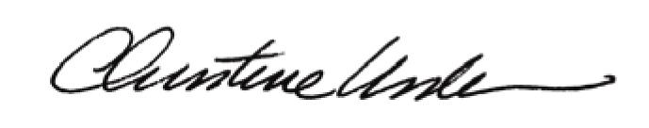

Date of Meeting: November 18, 2013 Title: Historic Officer

